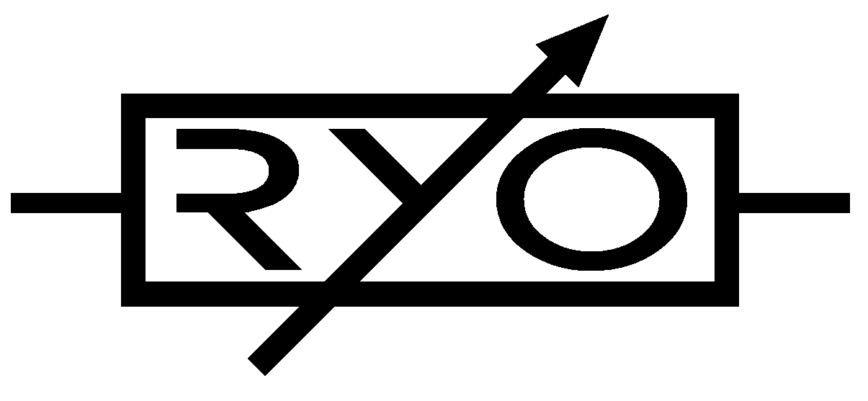
LjunggrenAudio RYO Optodist Datasheet:

Dimensions
Height: 3U [128.5mm],
Width: 6HP [30mm],
Depth: 31mm (with power cable attached)

Weight: ???g

Current consumption
+12V rail min 13mA to max 16mA
-12V rail min 13mA to max 16mA
+5V rail no +5V supply required

[There are small power variations between different vactrol and LED varieties. The option requiring least power is SR3 optocoupler paired with green limiter LEDs.]

Basic specifications
total frequency controllable range dc to 50 kHz
max input/output audio signal 20 Vpp
CV input range (calibrate to preference) 0V to +10V max

Max gain 0dB gain with +8V @ cv input
(calibrated as VCA) -40dB gain with 0V @ cv input

Nominal impedances
Audio signal input: 100k ohm
Audio Signal output: 1k ohm
CV input: 100k ohm

